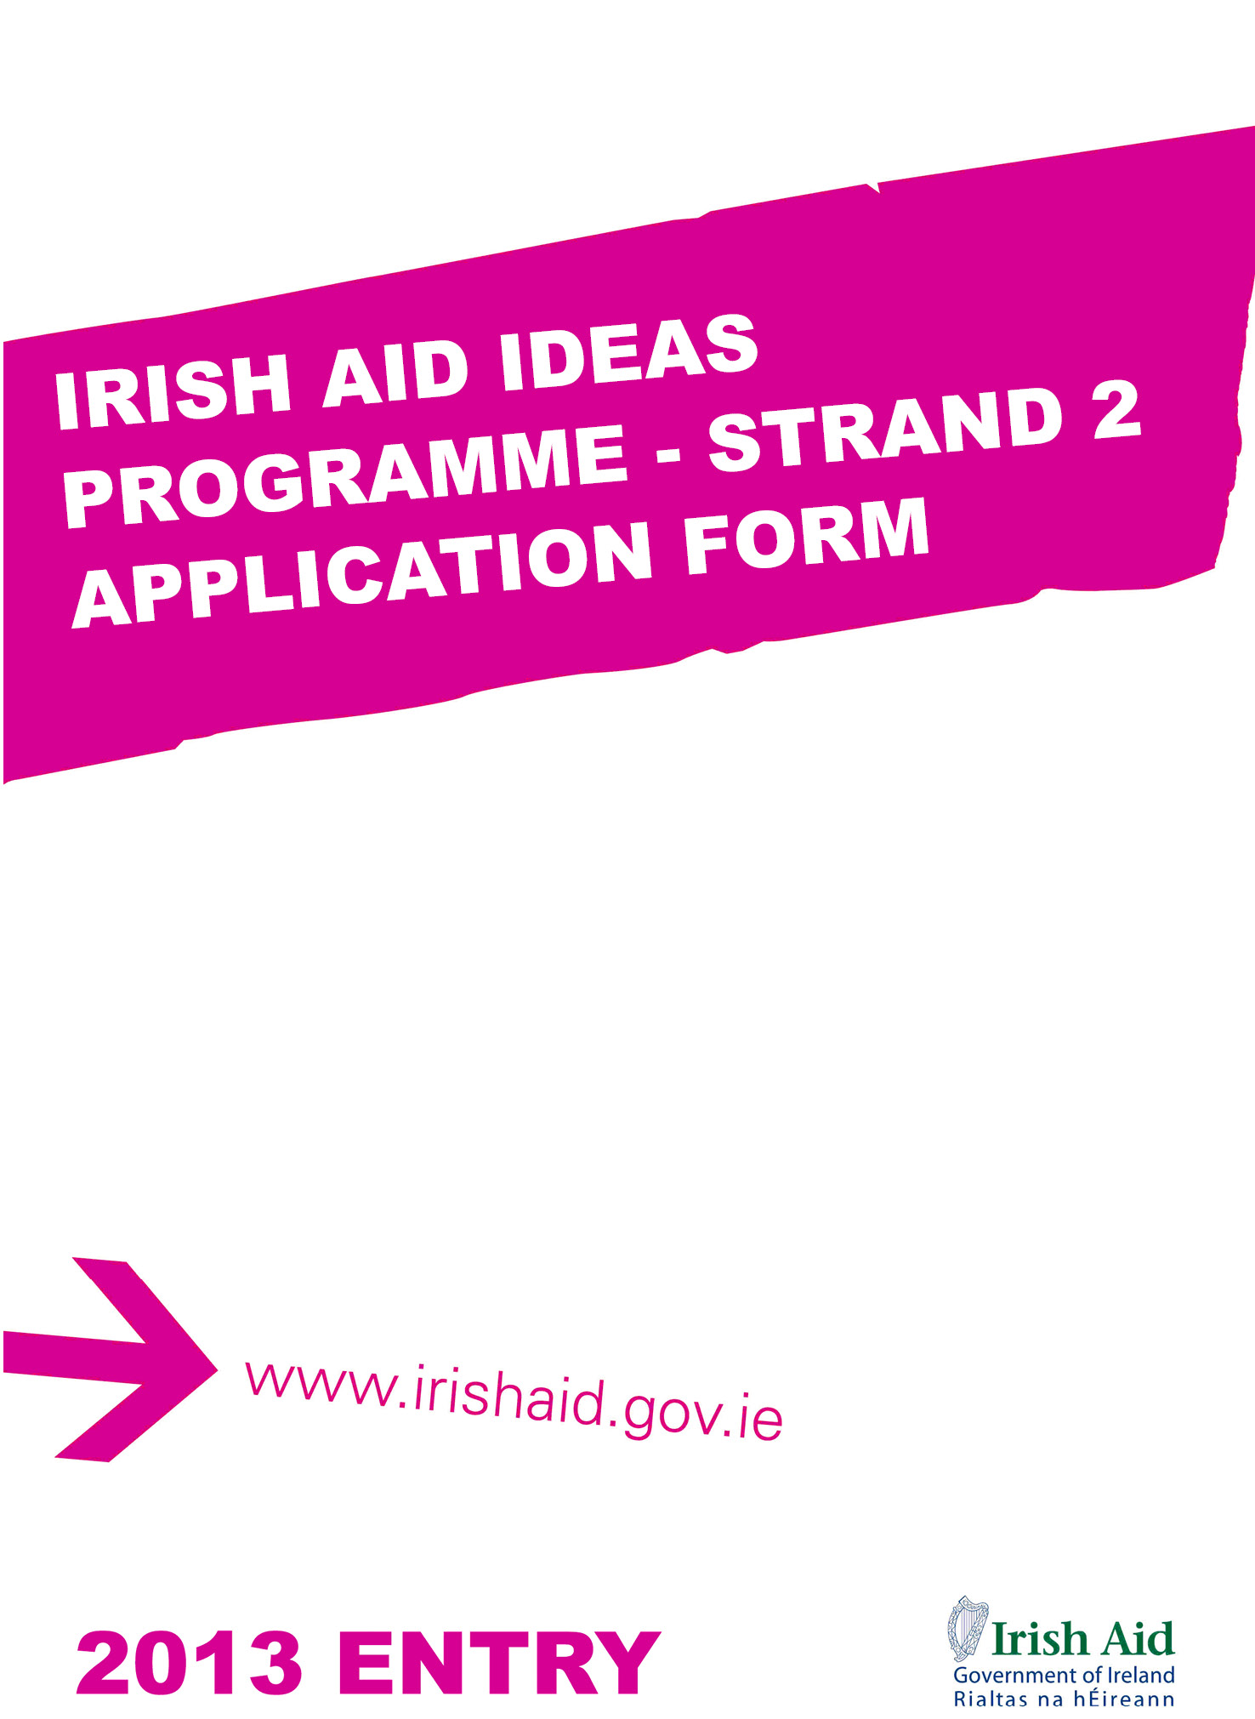

IRISH AID

The Government of Ireland’s official programme of assistance to developing countries is managed by Irish Aid, a directorate within the Department of Foreign Affairs and Trade. The aid programme focuses on the fight against poverty and hunger in some of the world’s least developed countries. It provides assistance to over 90 countries worldwide, including nine programme countries (which includes Vietnam), where there is a commitment to long term strategic assistance. The programme works in partnership with governments and communities in the developing world in their attempts to alleviate poverty through helping them meet basic needs and through strengthening their capacity to help themselves.

IRISH AID IDEAS PROGRAMME: STRAND 2

The Irish Aid IDEAS Programme is part of Irish Aid’s broad programme of support to capacity building in developing countries. The Programme aims to address capacity deficits that hinder the attainment of long-term development goals in Vietnam through the training and development of key individuals, generally drawn from the public services and NGO sectors.

The programme offers a number of study fellowship awards annually to candidates to further their education in Ireland at Master’s or post-graduate Diploma level.

Irish Aid invites applications from the staff of partner organisations working in collaboration with the Irish Aid programme in-country. These include government ministries and those in the non-governmental sector including civil society groups. Only candidates nominated by an Irish Aid partner organisation (i.e. higher education institutions and officials at relevant government agencies) to participate in the IDEAS Strand 2 programme are eligible to apply.

Irish Aid particularly welcomes candidates from ethnic minorities, candidates living with a disability or candidates from disadvantaged groups in Vietnam.

Fellowship recipients are committed, on completion of their training, to return home to resume work and put their acquired skills into practice for the benefit of the wider community.

IRISH COUNCIL FOR INTERNATIONAL STUDENTS

The Irish Council for International Students (ICOS) – www.icosirl.ie - provides support for the management and administration of the Irish Aid IDEAS Programme. This includes the provision of various support services for fellowship holders. ICOS is an independent non-profit organisation that promotes best practice in relation to the recruitment, access and support of international students in Irish education.

ELIGIBILITY REQUIREMENTS

To be eligible for an Irish Aid IDEAS Fellowship, applicants must:

- be a citizen of Vietnam and be residing in Vietnam
- provide a letter from their employer granting study leave for the duration of the fellowship and guaranteeing that they will be able to return to an equivalent position in the organisation at the end of the fellowship period.
- have met any relevant procedural requirements of the Government of Vietnam
- have achieved the necessary standard to be accepted onto a Postgraduate Diploma or Masters course in a Higher Education Institute in Ireland or within their own region.
- have a minimum of two years relevant work experience in development.
- have identified relevant college courses in a Higher Education Institute in Ireland
- be able to demonstrate a strong commitment to the development of their home country.
- be able to take up the fellowship in the academic year for which it is offered.
- provide an original copy of a previous English Language test result - IELTS (minimum 6.5) or TOEFL (minimum 570) - taken within two years of the application date

If offered an Irish Aid Fellowship, candidates will be required to:

- undergo a medical examination prior to confirmation of the fellowship award.
- be able to satisfy immigration requirements for international student entry to Ireland, if applicable.
- sign a ‘Form of Undertaking’ that they will return to their organisation for a minimum period of two years following completion of their fellowship in order to contribute to their country’s development.

FELLOWSHIP APPLICATION PROCESS

The closing date for receipt of applications to the Embassy of Ireland in Vietnam is 1 March 2013. The Fellowship Selection Committee will meet in March to short-list fellowship applications and conduct interviews. Applicants who successfully complete Stage 1 will be notified by the end of March 2013 and will proceed to Stage 2.

Course Application

Candidates for Stage 2 will be contacted by ICOS in April 2013 regarding submission of course applications.

To go through to the final selection stage in June, candidates must ensure that they apply for their chosen college course(s) through the specific application channel listed at the end of each course entry in the IDEAS Strand 2 Course Directory (available from the Embassy of Ireland in Hanoi). Most Irish Higher Education Institutes operate an online application system.

The following institutions operate through a separate central online portal called Postgraduate Application Centre or PAC (www.pac.ie).

- Dublin City University
- University College Cork
- NUI Galway
- NUI Maynooth
- Waterford Institute of Technology

The college application fee will be paid by ICOS on behalf of Irish Aid but the shortlisted applicant is responsible for ensuring that they submit their application to the college including all relevant supporting documentation no later than 10 May.

If a candidate does not fulfil college application requirements by the specified date their fellowship application will not go forward to the final selection stage.

Further Information

Information on the Irish Aid IDEAS Programme, including the application process and a directory of eligible postgraduate courses, is available from the Embassy of Ireland in Hanoi. General information on Irish Aid Fellowships and studying in Ireland can be accessed from the ICOS website - www.icosirl.ie. All academic courses in Ireland commence in the period August to October each year.

APPLICATION REQUIREMENTS

For your application to be considered, it is important that you:

- fill out all relevant sections in this application form
- sign the application declaration (Section 7)
- include three recent passport-size photographs
- include a statement of intent, using the headings below
- include all relevant supporting documents, as listed in Section 9.

Applications with unanswered questions or missing documentation will be deemed incomplete and will not be considered for a fellowship.

Please note that a checklist of required documents is presented in Section 9.

Statement of Intent

You are requested to provide a typed statement of intent - in 800 to 1,000 words - which follows the headings below:

- The key achievements in your career to date (7 marks)
- Why do you want to pursue your nominated course? (7 marks)
- How do you see yourself using your new skills and knowledge when you return to work? (4 marks)
- Briefly suggest how your proposed study will contribute to future development in your country? (4 marks)

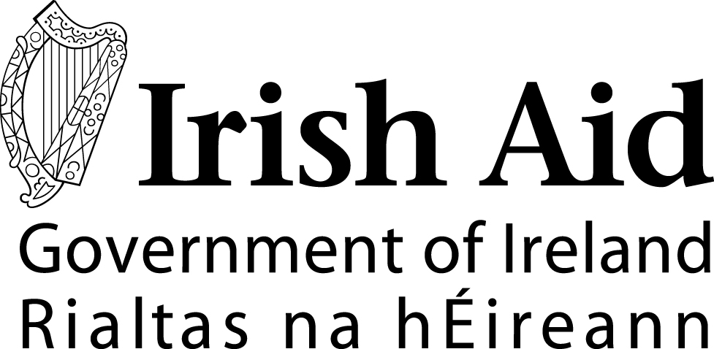  IDEAS Programme: Strand 2 – 2013 Application Form  Closing Date: 1 March 2013  This form is designed to be completed in Microsoft Word. If you need to complete by hand, please write in BLOCK CAPITAL LETTERS in black ink.  Your application will be photocopied. Documents should be stapled together in the top left corner. Please do not use spiral or other binding.  The introductory pages of this form (i.e. the cover and i-iii) should be removed and retained for reference when submitting. | Please  attach three recent  passport-size photographs of  yourself here.  (Attach using glue  not staples or tape.  If your photos are in  a strip, you do not  need to cut them)
SECTION ONE: PERSONAL INFORMATION
- Please write your full official name as recorded in your passport. If you do not have a passport, please write your name in the order it would appear in an official document.

Full Name:

What name do you like to be known by?:
(i.e. your first name or given name)
2. Male Female

3. Date of Birth / / (Day / Month / Year)

4. Place of Birth

5. Ethnicity

6. Family Details

Married or single: Married Single

Number of children (if any):

Any other dependents:
7. Do you have a passport? * Yes No

If yes, please give details as follows:
Type (Normal/Diplomatic, etc.):

Date of issue : / / (Day/Month/Year) Date of expiry : / /

*Your passport should be valid for the duration of your study period.
8. Have you been convicted of a criminal offence? Yes No

If the answer is Yes, please provide details of the offence for which you were convicted, including the nature of the offence and the sentence received.

9. The fellowship application process takes several months. Please provide a street address (not a PO Box) where you can be contacted when a decision is made (usually your home address) and also a PO Box address if you have one.

- Home Address (please include city and country):

B) PO Box Address, if applicable (please include city and country):

Contact phone numbers: (Please give at least two numbers if possible, e.g. work, mobile, landline)

Your main telephone number :

Other telephone number (1):

Other telephone number (2):

Clearly write an email address for an account which is checked regularly.

Email:

10. Name someone who can be contacted in an emergency.

Name:
Relationship to you (e.g. spouse, father, mother, sibling):
Home Address (please include city and country):

What telephone numbers can be used to contact them? (Please give at least two numbers if possible)

Main telephone number:

Other telephone number:

Clearly write an email address for an account which they check regularly.

Email:

SECTION TWO: EDUCATION, QUALIFICATIONS AND SCHOLARSHIPS
- You must provide a certified copy of the academic transcripts and completion certificate for each qualification you have completed. Include a certified copy of the grade assessment schedule for each qualification.

Qualification | Educational Institution | Dates  From – To  (Month/Year) | Location | Final Grade Achieved

- Please give details of any professional qualifications awarded including dates, awarding body and type of award received.

13. Please give details of any educational or vocational training courses attended (other than those mentioned in Q11/12), including dates, training body and certification received, if applicable.

14. Have you previously received a scholarship or award funded by any government or international organisation?

Yes No

If you answered Yes, write the name of the scholarship, the year(s) on scholarship and the name of the qualification or course undertaken.

i.

ii.

15. Have you ever previously applied for an Irish Aid Fellowship?

Yes No

If yes, please list year(s) in which you previously applied and if you were successful:

16. Have you applied, or are you intending to apply, for another scholarship at the same time as this application?

Yes No

If you answered Yes, provide the full name of the sponsor and the scholarship.

Sponsor:

Scholarship:

SECTION THREE : EMPLOYMENT DETAILS
17. Please provide the following information in relation to your current employment:

Employing Organisation:

Address (please include city and country):

Telephone: Fax:

E-mail:

18. What type of organisation do you work for?

Local Government Community/Non-Government Organisation (NGO)
Central Government Faith-based Organisation
Multilateral Agency International NGO
Private Sector Other (please state):

19. Date you started with this organisation: / / (Day/Month/Year)

Title of current post:

Date you started in this post: / / (Day/Month/Year)

List in chronological order the previous positions held in this organisation and dates (please provide month and year of commencement of position):

20. Briefly describe the work of your organisation:

21. Please provide details of your current responsibilities:

22. What will be your likely future position and responsibility after completion of the course?

23. Please provide information, on your previous employment, if applicable.

Name of Organisation | Address | Dates  From-To  (Month and Year) | Location | Position Held  Tasks and Responsibilities

SECTION FOUR : ENGLISH LANGUAGE COMPETENCY
24. Have you completed an IELTS (International English Language Testing System) academic test?*

No Yes

I have attached the original copy of my IELTS result to this application form.

Date of test: / / (Day/Month/Year)

Overall IELTS (academic stream) score:

Listening band: Reading band: Writing band: Speaking band:

25. Have you completed a TOEFL (Test of English as a Foreign Language) test?

No Yes

I have attached the original copy of my TOEFL result to this application form.

Date of test: / / (Day/Month/Year)

(Internet-based) TOEFL score: or (Paper-based) TOEFL score:

Test of Written English (TWE) score:

If applying to study at an Irish Higher Education Institute, you are required to meet the minimum English language proficiency of scores IELTS 6.5 or TOEFL 570. No exceptions are made. Tests results must be no more than 24 months old.

SECTION FIVE: PROPOSED COURSE
26. List the programme title and the college for your first and second choice courses.

Please choose carefully. You will not normally be permitted to revise your choices after submission, unless a programme does not run. You should ensure that you meet all entry requirements for the academic course you intend applying for. These can be found in the IDEAS Strand 2 Course Directory and the relevant college website.

Note: Masters Degrees by Research are not eligible for the programme.

First Course Choice

Title and Level of Course:

Name of Educational Institute:

Course Code: (if available)

Course start date: / (Month/Year) Course Duration:
Second Course Choice

Title of Course:

Name of Educational Institute:

Course Code: (if available)

Course start date: / (Month/Year) Course Duration:

SECTION SIX: ACADEMIC REFEREES
- Please provide details of the two academic referees who are supporting your application. You should submit their reference letters with this form. They may also be contacted for further information.

Academic referees should normally be lecturers who have taught a candidate at degree or postgraduate diploma level, are familiar with their academic work at that level and are in a position to offer relevant comment regarding a candidate’s suitability for their proposed masters’ programme.

Name:

Organisation/Institute:

Address (please include city and country):

Telephone Number: Fax Number:

Email Address:

Name:

Organisation/Institute:

Address (please include city and country):

Telephone Number: Fax Number:

Email Address:

SECTION SEVEN: DECLARATION
I am in good health and if accepted for an Irish Government Study Fellowship will undertake the necessary medical examinations and provide the required medical certificates.

I understand the purposes for which the Irish Government Study Fellowships are awarded, the necessity to abide by the conditions specified, and I accept the requirements to return to my country to work for my current employer for an agreed period on completion of my studies.

I certify that all the information I have given is true, complete and accurate to the best of my knowledge.

Signature: Date: / / (Day/Month/Year)

SECTION EIGHT : EMPLOYER ENDORSEMENT
This section must be completed (in English) and signed on p14 by the applicant’s supervisor.

29. Endorsed by Department/Organisation:

Address (please include city and country):

Telephone: Fax:

E-mail:

30. Will the applicant be granted study leave?

No Yes

31. Please attach a reference letter, written on your organisation’s official letter head and bearing an official stamp and signature of supervisor, which answers the following questions:*

- Why is your organisation nominating this candidate?
- What specific skills do you expect the nominee to gain from participation in the master’s degree programme?
- Describe how the nominee’s newly acquired knowledge and skills will build capacity within your organisation.
- At the end of the study will the nominee be able to return to a position at least equivalent to the one he or she holds at present?
- After the study would the nominee have a new position in your organisation? If Yes, name the new position.

*Please note that only applications with this information in full will be considered.

>> continues overleaf

SECTION EIGHT : EMPLOYER ENDORSEMENT (CONTINUED)
CAPACITY BUILDING

32. This section must be completed (in English) by the nominee’s employer.

- Please list courses of study chosen by your nominee:

- How do the courses of study either a) fill gap in terms of skills available in your organisation or b) build on the existing strengths in your organisation?

- Why has the organisation identified this nominee for future training?

- How will your organisation support this nominee to build the capacity of the organisation on his/her return?

33. Name of authorising official:

Job Title:

Signature:

Date: / / (Day/Month/Year) Official Stamp

SECTION NINE: DOCUMENTATION CHECKLIST
All relevant documents listed below must be included with your application, in the sequence shown.

Supporting documents must be certified true copies of original documents with the official stamp and signature of a Justice of the Peace, Solicitor, Notary Public, an official from an Embassy of Ireland, or another authorised official. Photocopies of certified documents are not acceptable but a certified photocopy of a document with an original certification is acceptable. Where original documents are not in English, you must provide certified true copies of official English translations.

You should mark the boxes below to indicate that all documents are present. If you do not possess a particular document (e.g. birth certificate) you should explain in the notes section below.

Essential

Statement of Intent (see page iii)
A current (dated) curriculum vitae - a brief history of your education, work experiences and skills, including exact dates e.g. month/year in which you started and completed your studies, work experiences. Maximum 2 pages.
A certified copy of the completion or graduation certificate for each tertiary qualification that you have completed (in English).
A certified copy of the academic transcript for all tertiary qualifications and the grading schedule for each qualification (in English).
An employer’s reference letter on official letterhead, supporting your Irish Aid fellowship application for your proposed study (please refer to Q31). Question 32 must also be completed.
Letters from your two academic referees (Q27)
A certified copy of your birth certificate (in English)
A certified copy of the identity pages of your passport
The original international English proficiency test result, e.g. IELTS or TOEFL. Photocopies will not be accepted. Test results must be no more than 24 months old by the commencement of study.

If applicable:

A certified copy of official evidence of any name change (in English).

NOTES ON DOCUMENTATION:

