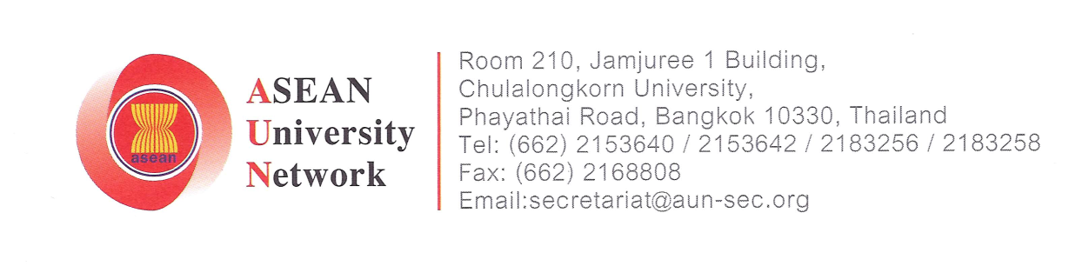

AUN-AELP 2017
DATE | TIME | ACTIVITY | VENUE
Saturday  22 July 2017 |  | Arrival & Registration | EDC Hotels & Resorts
Saturday  22 July 2017 | 8.00 pm | Dinner | EDC Hotels & Resorts
Saturday  22 July 2017 | 8.00 pm | Ice-breaking & House Keeping | EDC Hotels & Resorts
Sunday  23 July 2017 | 8.00 am | Visit to UUM Welcome Centre | UUM Welcome Centre
Sunday  23 July 2017 | 9.00 am | Lecture with Royal Malaysian Army (Theory) | EDC Hotels & Resort
Sunday  23 July 2017 | 10.30 am | Tea Break | EDC Hotels & Resorts
Sunday  23 July 2017 | 10.45 am | Lecture with Royal Malaysian Army (Theory) | EDC Hotels & Resorts
Sunday  23 July 2017 | 12.00 pm | Lunch | EDC Hotels & Resorts
Sunday  23 July 2017 | 2.15 pm | Group Discussion / Sharing session | EDC Hotels & Resorts
Sunday  23 July 2017 | 5.30 pm | Alor Setar City Tour | Alor Setar
Sunday  23 July 2017 | 10.00 pm | Break | EDC Hotels & Resort
Monday  24 July 2017 | 8.30 am | Field Training Exercise I | UUM
Monday  24 July 2017 | 10.00 am | Tea Break | UUM
Monday  24 July 2017 | 10.30 am | Field Training Exercise II | UUM
Monday  24 July 2017 | 12.30 pm | Lunch | UUM
Monday  24 July 2017 | 2.00 pm | Field Training Exercise III | UUM
Monday  24 July 2017 | 7.00 pm | Dinner | UUM Arts & Cultural Centre
Monday  24 July 2017 | 7.00 pm | Cultural Night | UUM Arts & Cultural Centre
Monday  24 July 2017 | 11.00 pm | Break | EDC Hotels & Resorts
Tuesday  25 July 2017 | 9.00 am | Breakfast | EDC Hotels & Resorts
Tuesday  25 July 2017 | 10.00 am | Special slot with Royal Malaysian Army | UUM
Tuesday  25 July 2017 | 12.00 pm | Lunch | UUM
Tuesday  25 July 2017 | 2.00 pm | Reflection session
Tuesday  25 July 2017 | 5.00 pm | Discover UUM  -Pokok 3 beradik (60 participants)  - Golf  - Go kart  -Hidden Lake  -Tram / ATV / OTV / Horse Carriage | 13 – 15 participants
Tuesday  25 July 2017 | 8.30 pm | Closing ceremony | EDC Hotels & Resorts
Tuesday  25 July 2017 |  | Break | EDC Hotels & Resorts
Wednesday  26 July 2017 |  | Departure

Updated : 13 April 2017

